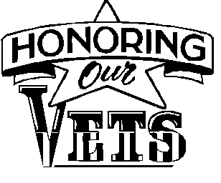

“Run for a Vet” Sponsorship Opportunities
We invite you to consider becoming a sponsor for the Branson Veterans of America’s 9th Annual
“Run for a Vet 5k and ½ Marathon” held June 8th, 2024.

Presenting Sponsor $2,500+
- Headline sponsor exclusivity
- Special acknowledgment as “Presenting Sponsor” in marketing and social media presentations
- Prominent largest logo placement on event T-shirt
- 10 Race Registrations
- 10 Event T-shirts
- Recognition at event with speaking opportunity
- Business promotional materials may be added to event packet
- Optional - Company banner displayed at event (business supplies banner)
- Optional - Provide hosting site of pre-event registration packet pick-up
- Optional - Opportunity to host water station at half way point

Hero Sponsorship $1,000+
- Business/Organization name and logo listed on the back of event T-shirts
- Business mentioned on social media promotions
- 8 Race Registrations
- 8 Event T-shirts
- Optional - Company banner displayed at event (business supplies banner)

Warrior Sponsorship $ 500+
- Business/Organization name and logo listed on the back of event T-shirts
- Business mentioned on social media promotions
- 4 Race Registrations
- 4 Event T-shirts

Patriot Sponsorship $ 250+
- Business/Organization name and logo listed on the back of event T-shirts
- Business mentioned on social media promotions
- 2 Race Registrations
- 2 Event T-shirts

Sponsors will be recognized periodically on BVA 913’s Facebook Page, and will be promoted whenever appropriate throughout the marketing campaign. All proceeds will go to Branson Veterans of America 913.

